**Profile**

**Name of the School/Institute: Getana Primary School**

**Year of Establishment: 2000**

**Total Land area: 8.5 acre**

**Classes/ Courses Offered: Classes PP - VI**

**Total Students:**

* Male : 47
* Female : 54

**Total Teachers:**

* Male : 4
* Female : 5

**Support Staff:**

* Male : 6
* Female: 3

**Infrastructure and Facilities (**please mention the existing infrastructure and facilities institute provides)

1. Principal Quarter : 1

2. Administration Block – inclusive of following:

i. Principal Office

ii. Staff room

iii. General Store room.

3. One academic block with three units.

4. One old academic block with two units.

5. One temporary Kitchen cum dining hall

6. One old teacher quarter with two units

7. One temporary teacher quarter.

8. One mini football ground.

9. One temporary ECCD classroom.

10. One small play ground for ECCD

**Brief Background on the Institute:**

(Establishment of the school, Reasons for its establishment and location, infrastructure & facility development, course introduction, etc may be mentioned in chronological order to illustrate the key development areas)

**Statistics of Students 2023:**

|  |  |  |  |  |  |  |  |  |  |  |
| --- | --- | --- | --- | --- | --- | --- | --- | --- | --- | --- |
| **SL. No** | **Classes** | **Border** | | | **Day scholar** | | | **Grand Total** | | |
| Boys | Girls | Total | Boys | Girls | Total | **Boys** | **Girls** | **Total** |
| 1 | PP | 4 | 5 | 9 | 2 | 4 | 6 | **6** | **9** | **15** |
| 2 | I | 5 | 4 | 9 | 2 | 1 | 3 | **7** | **5** | **12** |
| 3 | II | 7 | 7 | 14 | 2 | 4 | 6 | **9** | **11** | **20** |
| 4 | III | 4 | 7 | 11 | 2 | 2 | 4 | **6** | **9** | **15** |
| 5 | IV | 5 | 6 | 11 | 2 | 1 | 3 | **7** | **7** | **14** |
| 6 | V | 4 | 7 | 11 | 2 | 1 | 3 | **6** | **8** | **14** |
| 7 | VI | 5 | 5 | 10 | 1 | 0 | 1 | **6** | **5** | **11** |
| **Total** | | **34** | **41** | **75** | **13** | **13** | **26** | **47** | **54** | **101** |

**Enrollment as per the catchment area**

**Teaching Staff Details:**(Please don’t add title –Mr/Mrs/Ms- before the name)

|  |  |  |  |  |  |
| --- | --- | --- | --- | --- | --- |
| Sl.no | Name | Qualification | Subject/ taught | Years in Service | Nationality |
| **1** | **Mr. Dorji Tshering** | **B.Ed(Pry)** | **General** | **27 years** | **Bhutanese** |
| **2.** | **Mr.Pema Thinley** | **B.Ed(Pry)** | **General** | **5 years** | **Bhutanese** |
| **3.** | **Ms.Pema Zangmo** | **DzoB.Ed(Pry)** | **Dzongkha** | **5 years** | **Bhutanese** |
| **4.** | **Mrs.Tandin Lhamo** | **B.Ed(Pry)** | **General** | **3 years** | **Bhutanese** |
| **5.** | **Ms. Chencho Pemo** | **Dzo.B.Ed(Pry)** | **Dzongkha** | **2 years** | **Bhutanese** |
| **6.** | **Mr.Sonam Tshewang** | **B.Ed(Pry)** | **General** | **2 years** | **Bhutanese** |
| **7.** | **Mrs. Rinchen Pemo** | **B.Ed(Pry)** | **General** | **2 years** | **Bhutanese** |
| **8.** | **Mr.Tshering Norbu** | **B.Ed(Pry)** | **General** | **1 year** | **Bhutanese** |
| **9** | **Mrs. Dorji Seldon** | **B.Ed(Pry)** | **General** | **1 year** | **Bhutanese** |

**Teaching Supporting Staff Details:**(Please don’t add title –Mr/Mrs/Ms- before the name)

|  |  |  |  |  |  |
| --- | --- | --- | --- | --- | --- |
| Sl.no | Name | Qualification | Subject/ Courses taught | Years in Service | Nationality |
| **1** | **Sonam Tobgay** | **XII** | **ADM.Asst** | **5 years** | **Bhutanese** |
| **2** | **Kezang** | **XII** | **ECCD Faciliotator** | **5 years** | **Bhutanese** |
| **3** | **Sonam Wangchuk** | **XII** | **SSI** | **1 year** | **Bhutanese** |
| **4** | **Kinley Pelmo** | **XII** | **Caregiver** | **1 year** | **Bhutanese** |
| **5** | **Lhab Tshering** | **XII** | **NFE Instructor** | **7 years** | **Bhutanese** |
|  |  |  |  |  |  |
|  |  |  |  |  |  |

**ESP/GSP Staff Details:**(Please don’t add title –Mr/Mrs/Ms- before the name)

|  |  |  |  |  |  |
| --- | --- | --- | --- | --- | --- |
| Sl.no | Name | Qualification | Subject/ Courses taught | Years in Service | Nationality |
| **1** | **Khotsho** | **VI** | **Cook** | **10 years** | **Bhutanese** |
| **2** | **Jabchu** | **Nil** | **Cook** | **6 years** | **Bhutanese** |
| **3** | **Pema Wangmo** | **VII** | **Sweeper** | **6 years** | **Bhutanese** |
| **4** | **Yeshi** | **IX** | **Caretaker** | **7 years** | **Bhutanese** |
|  |  |  |  |  |  |
|  |  |  |  |  |  |

**Profile of the Principal**

ize Photo

Name : Dorji Tshering

DoB: 03-03-73

Qualification: B.Ed Primary

Designation: Principal

Position title / Level: P3 A

CID No.: 10711000437

EID No.: 9507305

Nature of work: Regular

Date of Joining in Service: 01- 07- 1995

Date of Joining in the Present school: 20 – 02 – 2008

Home Address: Village:– Jangdung, Gewog:– Saling, District:– Mongar

House No: JA – 11 – 14 Thram No: 172

E-mail: [dtring30@yahoo.com](mailto:dtring30@yahoo.com) Telephone: 17658276

Father’s Name: Late Tshewangla

Village:– Jangdung, Gewog:– Saling, District:– Mongar

Mother’s Name: Namo

Village:– Jangdung, Gewog:– Saling, District:– Mongar

Educational Background: (please begin with your present qualification)

|  |  |  |
| --- | --- | --- |
| Qualification | Year | Institution |
| Degree | 15th December, 2015 | Samtse college of Education |
| Diploma in Management | 30th January, 2009 | Paro College of Education |
| PTTC | 28th June, 1995 | Samtse NIE |
|  |  |  |

Professional Experience: (please begin with your present post and assignment)

|  |  |  |
| --- | --- | --- |
| Professional Experience | From - To | Place of Assignment |
| Principal | 2008 – till date | Ketokha PS |
| Principal | 2005 - 2007 | Autsho PS |
| Headmaster | 2000 - 2004 | Getana PS |
| Teacher | 1995 - 1999 | Bongo PS |

**Profile of the Teacher**

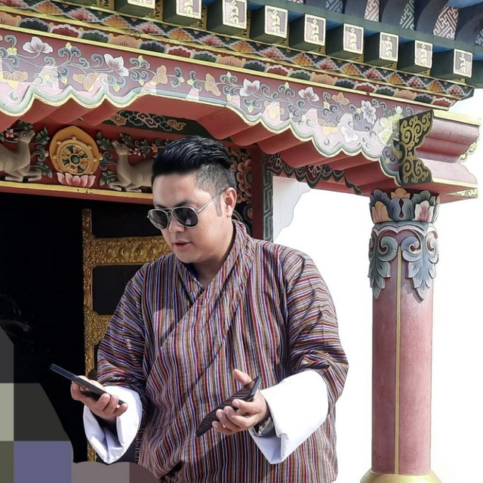

Name: Pema Thinley

DoB: 1/1/1991

Qualification: B.Ed Primary

Designation: Teacher III

Position title / Level: P5A

CID No.: 11914001369

EID No.: 20190113107

Nature of work: Regular

Date of Joining in Service: 1/1/2019

Date of Joining in the Present school: 2/1/2019

Home Address: Village:– Rukubji

House No: Tsha-14-135 Thram No: 144

E-mail: [pthinley2019@education.gov.bt](mailto:pthinley2019@education.gov.bt) Contact No: 17673659

Father’s Name: Late Tshering Dorji

Village: Rukubji Gewog: Saephu District: Wangduephodrang

Mother’s Name: Late Gyem Lham

Village:–Rukubji Gewog:– Saephu District:– Wangduephodrang

Educational Background: (please begin with your present qualification)

|  |  |  |
| --- | --- | --- |
| Qualification | Year | Institution |
| Degree | 16th June, 2018 | Paro College of Education |
| Class X | 16th December, 2008 | Mongar Higher Secondary School |
| Class XII | 16th December 2010 | Mongar Higher Secondary School |
|  |  |  |

Professional Experience: (please begin with your present post and assignment)

|  |  |  |
| --- | --- | --- |
| Professional Experience | From - To | Place of Assignment |
| Teacher | 2019 – till date | Getana PS, Chhukha |
|  |  |  |
|  |  |  |
|  |  |  |

**Profile of the Teacher**

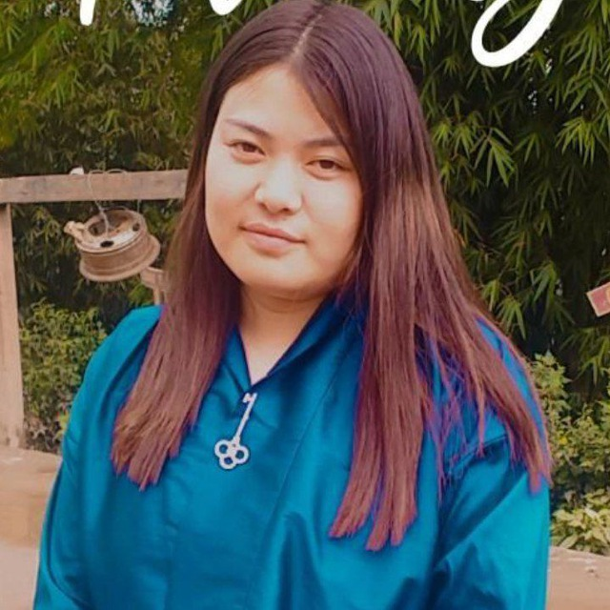

Name : Tandin Lhamo

DoB: 04/08/1994

Qualification: B.Ed Pry

Designation: Teacher I

Position title / Level: P5B

CID No.: 11501002433

EID No.: 20200317329

Nature of work: Regular Contract

Date of Joining in Service: 3/1/2020

Date of Joining in the Present school: 3/1/2020

Home Address: Village:– Tashi Teng

House No: Thram No: 195

E-mail: Contact No:

Father’s Name: Yeshi Wangdi

Village:, Gewog: District: Bartsham

Mother’s Name: Yeshi Lhamo

Village:– Gewog:– District:–

Educational Background: (please begin with your present qualification)

|  |  |  |
| --- | --- | --- |
| Qualification | Year | Institution |
| Degree | 18th December 2019 | Paro College of Education |
|  |  |  |
|  |  |  |
|  |  |  |

Professional Experience: (please begin with your present post and assignment)

|  |  |  |
| --- | --- | --- |
| Professional Experience | From - To | Place of Assignment |
| Teacher | 2019 – till date | Getana PS, Chhukha |
|  |  |  |
|  |  |  |
|  |  |  |

**Profile of the Teacher**

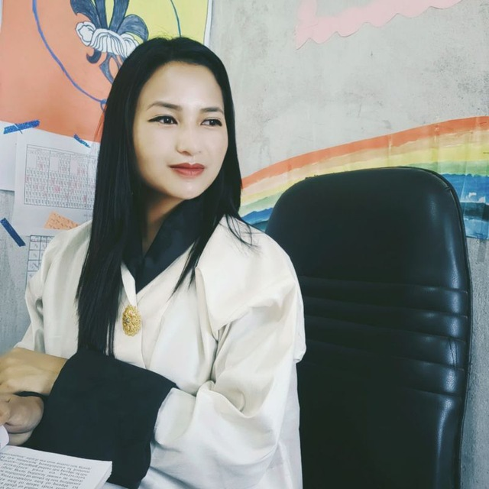

Name: Pema Zangmo

DoB: 17/12/1993

Qualification: B.Ed(Dzongkha)

Designation: Teacher

Position title / Level: P5A

CID No.: 11913001754

EID No.: 20190113053

Nature of work: Regular

Date of Joining in Service: 1/1/2019

Date of Joining in the Present school: 2/1/2019

Home Address: Village:– Rubesa

House No: Tsha-༡༣-Nill/༢༨ , Thram No:816

E-mail: pzangmo2019@education.gov.bt, Contact No: 17787606

Father’s Name: Chencho

Village:, Ruemeynang , Gewog: Rubesa, District:Wangdue Phodrang

Mother’s Name: Sigay Bidha

Village:– Ruemeynang, Gewog:– Rubesa, District:– Wangdue Phodrang.

Educational Background: (please begin with your present qualification)

|  |  |  |
| --- | --- | --- |
| Qualification | Year | Institution |
| Degree | 18th December 2018 | Paro College of Education |
|  |  |  |
|  |  |  |
|  |  |  |

Professional Experience: (please begin with your present post and assignment)

|  |  |  |
| --- | --- | --- |
| Professional Experience | From - To | Place of Assignment |
| Teacher | 2019 – till date | Getana PS, Chhukha |
|  |  |  |
|  |  |  |
|  |  |  |

**Profile of the Teacher**

Name:Chencho Dema

DoB: 10/5/1997

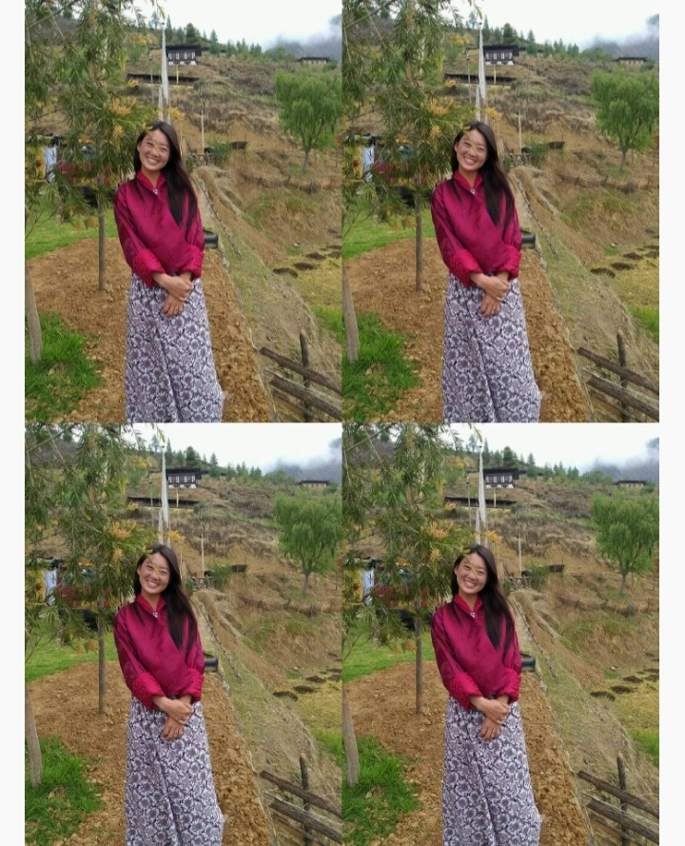

Qualification: B.Ed(Dzongkha)

Designation: Teacher

Position title / Level: P5A

CID No.: 10808001027

EID No.: 202106918898

Nature of work: Regular

Date of Joining in Service: 8/6/2021

Date of Joining in the Present school: 8/6/2021

Home Address: Village:– Lholing

House No: Nya-8-Nil-244 Thram No:766

E-mail: cdema2021@education.gov.bt Contact No: 17712986

Father’s Name: Lam Rinzin

Village:Lholing, Gewog:Shaba District:Paro

Mother’s Name: Chencho Zangmo

Village:– Lholing Gewog:–Shaba District:– Paro

Educational Background: (please begin with your present qualification)

|  |  |  |
| --- | --- | --- |
| Qualification | Year | Institution |
| Degree | 18th December 2020 | Paro College of Education |
|  |  |  |
|  |  |  |
|  |  |  |

Professional Experience: (please begin with your present post and assignment)

|  |  |  |
| --- | --- | --- |
| Professional Experience | From - To | Place of Assignment |
| Teacher | 2020 – till date | Getana PS, Chhukha |
|  |  |  |
|  |  |  |
|  |  |  |

**Profile of the Teacher**

Name:Sonam Tshewang

DoB: 15/10/1997

Qualification: B.Ed Pry

Designation: Teacher

Position title / Level:P5A

CID No.: 10713001341

EID No.: 202201920494

Nature of work: Regular

Date of Joining in Service: 28/01/2022

Date of Joining in the Present school: 28/01/2022

Home Address: Village:– Nagor

House No: Ja-13-121 Thram No:164

E-mail: [sonamtshewang175@gmail.com](mailto:sonamtshewang175@gmail.com)

Contact No: 17389350

Father’s Name: Mindu

Village:Nagor, Gewog: Silambi District:Mongar

Mother’s Name: Tshomo

Village:– Nagor Gewog:– Silambi District:– Mongar

Educational Background: (please begin with your present qualification)

|  |  |  |
| --- | --- | --- |
| Qualification | Year | Institution |
| Degree | 18th December 2018 | Paro College of Education |
|  |  |  |
|  |  |  |
|  |  |  |

Professional Experience: (please begin with your present post and assignment)

|  |  |  |
| --- | --- | --- |
| Professional Experience | From - To | Place of Assignment |
| Teacher | 2019 – till date | Getana PS, Chhukha |
|  |  |  |
|  |  |  |
|  |  |  |

**Profile of the Teacher**

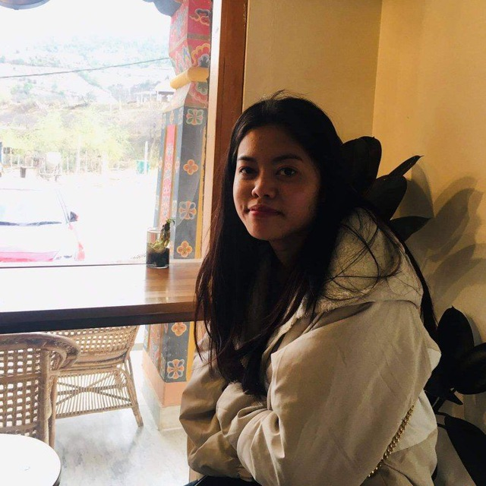

Name : Rinchen Pelmo

DoB: 21/03/1998

Qualification: B.Ed Pry

Designation: Teacher

Position title / Level: P5A

CID No.: 10708001891

EID No.: 202201920519

Nature of work: Regular

Date of Joining in Service: 28/01/2022

Date of Joining in the Present school: 28/01/2022

Home Address: Village:– Shingchongri

House No: Ja-8-125 Thram No:228

E-mail: [pemorinchen704@gamil.com](mailto:pemorinchen704@gamil.com)

Contact No: 17310509

Father’s Name: Doten Zangpo

Village:, Bedungri Gewog:Nganglam District. Pema Gatshel

Mother’s Name: Sangay Choezom

Village:– Shingchori:–Kengkar District:– Mongar

Educational Background: (please begin with your present qualification)

|  |  |  |
| --- | --- | --- |
| Qualification | Year | Institution |
| Degree | 18th December 2021 | Paro College of Education |
|  |  |  |
|  |  |  |
|  |  |  |

Professional Experience: (please begin with your present post and assignment)

|  |  |  |
| --- | --- | --- |
| Professional Experience | From - To | Place of Assignment |
| Teacher | 2022 – till date | Getana PS, Chhukha |
|  |  |  |
|  |  |  |
|  |  |  |

**Profile of the Teacher**

Name: Tshering Norbu

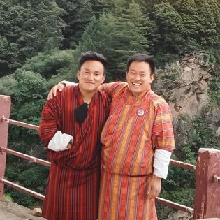

DoB: 23/1/1998

Qualification:B.Ed Pry

Designation: Teacher

Position title / Level: P5A

CID No.: 10713002006

EID No.: 202301922592

Nature of work: Regular

Date of Joining in Service: 6/2/2023

Date of Joining in the Present school: 6/2/2023

Home Address: Village:– Nagor pam

House No: JA-13-65 Thram No:215/603

E-mail: Contact No:

Father’s Name: Leki Dorji

Village:Nagor Pam, Gewog: Silambi District:Mongar

Mother’s Name: Lt.Ngwang Choden

Village:– Nagor Pam Gewog:– Silambi District:– Mongar

Educational Background: (please begin with your present qualification)

|  |  |  |
| --- | --- | --- |
| Qualification | Year | Institution |
| Degree | 18th December 2022 | Paro College of Education |
|  |  |  |
|  |  |  |
|  |  |  |

Professional Experience: (please begin with your present post and assignment)

|  |  |  |
| --- | --- | --- |
| Professional Experience | From - To | Place of Assignment |
| Teacher | 2023 – till date | Getana PS, Chhukha |
|  |  |  |
|  |  |  |
|  |  |  |

**Profile of the Teacher**

Name:Dorji Seldon

DoB: 01/07/1995

Qualification: B.Ed Pry

Designation: Teacher

Position title / Level:P5A

CID No.: 12007001143

EID No.: 202301922595

Nature of work: Regular

Date of Joining in Service: 6/2/2023

Date of Joining in the Present school: 6/2/2023

Home Address: Village:–

House No: Thram No:

E-mail: Contact No:

Father’s Name:

Village:, Gewog: District:

Mother’s Name:

Village:– Gewog:– District:–

Educational Background: (please begin with your present qualification)

|  |  |  |
| --- | --- | --- |
| Qualification | Year | Institution |
| Degree | 18th December 2022 | Paro College of Education |
|  |  |  |
|  |  |  |
|  |  |  |

Professional Experience: (please begin with your present post and assignment)

|  |  |  |
| --- | --- | --- |
| Professional Experience | From - To | Place of Assignment |
| Teacher | 2023 – till date | Getana PS, Chhukha |
|  |  |  |
|  |  |  |
|  |  |  |

**Profile of the Teacher**